CPAN-113: JavaScript Interactive Web Application Project Proposal
Group Members:
- Member 1: Avijit Singh
- Member 2: Chiu Li-Feng
- Member 3: David Perruzza
- Member 4: Joshua D’Angelo
Date: [11/03/2025]

1. Project Title
- [My Tasks Online]

2. Project Overview
- Description: This project is about to build a TODO task management system which build with JavaScript and will perform as a website page.
- Problem Statement: This project is aimed to provide a solution for create, modify, analysis and handle by a TODO website which offer several interfaces to demonstrate the task that user create. The website will compose by three different graphical user interface (GUI) which include task interface and calendar interface. The task interface will provide user to create, modify tasks with timestep record for both create and modify time. The calendar interface will offer user review the task that has been setup in an overall viewpoint using calendar system. Finally, the analysis interface will present the personal data analysis result of task which create by user.

3. Project Objectives
- Graphical user interface, three main user-friendly GUI which include task mode, calendar mode and analysis mode.
- Utilize cascading style sheets (CSS) for GUI design.
- Embedded image import and voice record function.
- Implement asynchronous programming using weather API.
- Import local file system to store user data.
- Adapting git and GitHub for project version control.
- Project task management that ensures all group members be part of project.

4. Key Features and Functionalities
- Graphical User Interface:
  - Todo page: User will management tasks through create, modify and delete function which build in TODO page.
  - Calendar page: The calendar page is able to provide calendar view which mark with TODO task that user create based on the create day and user is able to review the TODO task which setup before and future.
  - Analysis page: The analysis page will provide statistical analysis for todo task. The task will have four status which are incomplete, late, complete and wait process.
- Graphical User Interface Wireframe:
  - Todo page: 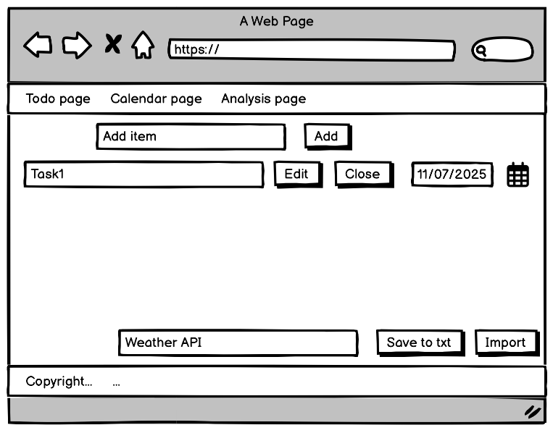
  - Calendar page: 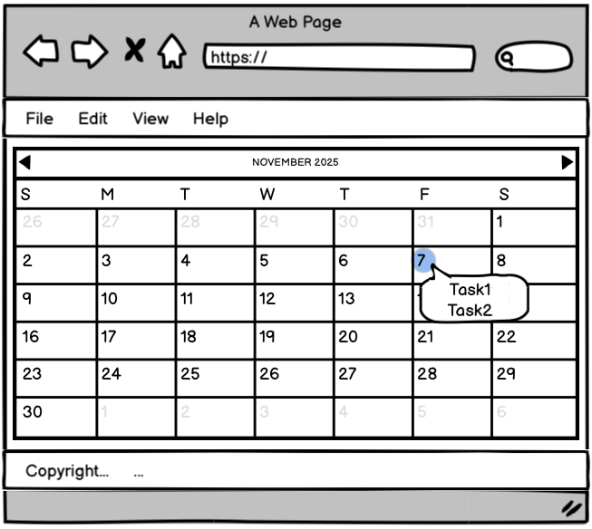
  - Analysis page: 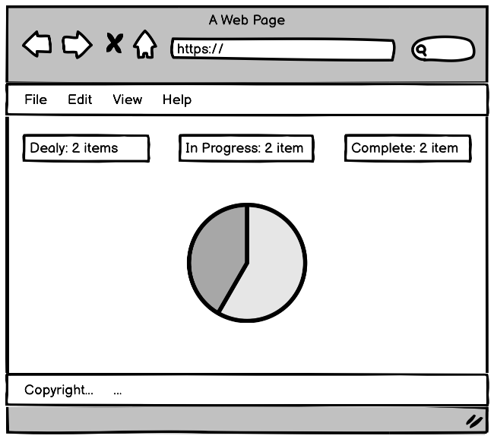

- Core Functionalities:
  - Button:
    - Create Task Button: This button will create a new task when user input content in input area when input area have no content but the button pushed it will appear an alarm message to notice user no content input.
    - Attach Image Button: When a task was creating user is able to through this button to attach image for current task, meanwhile this button only appear when mouse hover on it.
    - Voice Record Button: When a task creates by user the voice record button will build in the task area allow user to record voice for better task management.
  - Mouse click events:
    - Implement a function which provide user can drag and drop TODO task for sorting order that user desire in TODO page and Calendar page.
- Advanced Features:
  - API: Implement asynchronous function which integrate a weather API for display weather information for user at TODO page.

- Outline the main features the application will offer, such as:
  - User Interface: Describe how users will interact with the application.
  - Core Functionalities: Outline the planned JavaScript functionality, including events, control flow, DOM manipulation, and interactivity.
  - Advanced Features: Identify planned asynchronous tasks, API integrations, or other complex functions.

It is recommended to assign duties, tasks, and deadlines with as much detail as possible for a project. Be specific. Add more rows as needed in the following table.
Date | Tasks/Deliverables | Owner (Member Name)
11/09/2025 | Project Proposal Submission | Chiu Li Feng
11/15/2025 | GUI Header Design | Chiu Li Feng
11/15/2025 | GUI Footer Design | Chiu Li Feng
11/15/2025 | GUI Todo page Design | Chiu Li Feng
11/15/2025 | GUI Calendar page Design | David Perruzza
11/15/2025 | GUI Analysis page Design | Joshua D’Angelo
11/15/2025 | Create Task Button Function | Avijit Singh
11/22/2025 | Attach Image Button Function | David Perruzza
11/22/2025 | Voice Record Button Function | Joshua D’Angelo
11/22/2025 | Mouse Click Event Function | Avijit Singh
11/29/2025 | Weather API Function | Joshua D’Angelo
11/29/2025 | Task Save Function | Chiu Li Feng
11/29/2025 | Task Import Function | Chiu Li Feng
12/06/2025 | Project Presentation | All member

